DIDEROT Fellowships 2015
Support to postdoctoral mobility

Candidate Curriculum Vitae
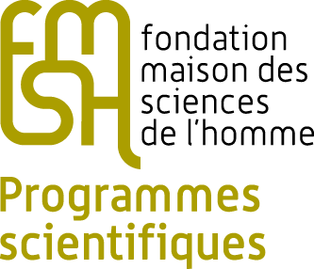
SURNAME, Name(s)
Date and place of birth
Nationality
Address
Email address
Telephone number
Latest diplomas obtained (degree type, institution, date of completion)
PhD thesis topic
PhD date and place of completion
Professional experience following PhD completion
Foreign languages (written and oral level)
Latest publications (5 maximum)
Current position

